Ideation Phase
Brainstorm & Idea Prioritization Template
Date | 14 July 2026
Team ID
Project Name | HouseRent India — MERN Property Rental & Sale Platform
Maximum Marks | 4 Marks

Step-1: Team Gathering, Collaboration and Problem Statement Selected
The team reviewed all four problem statements (PS-1 to PS-4) from the empathy and problem-definition exercises and selected the combined renter/owner trust-and-visibility gap as the core problem to solve: there is no single trusted platform where owners can list rent/sale properties and renters/buyers can discover, request, and communicate about them directly.

Step-2: Brainstorm, Idea Listing and Grouping
Ideas generated by the team, grouped into themes:
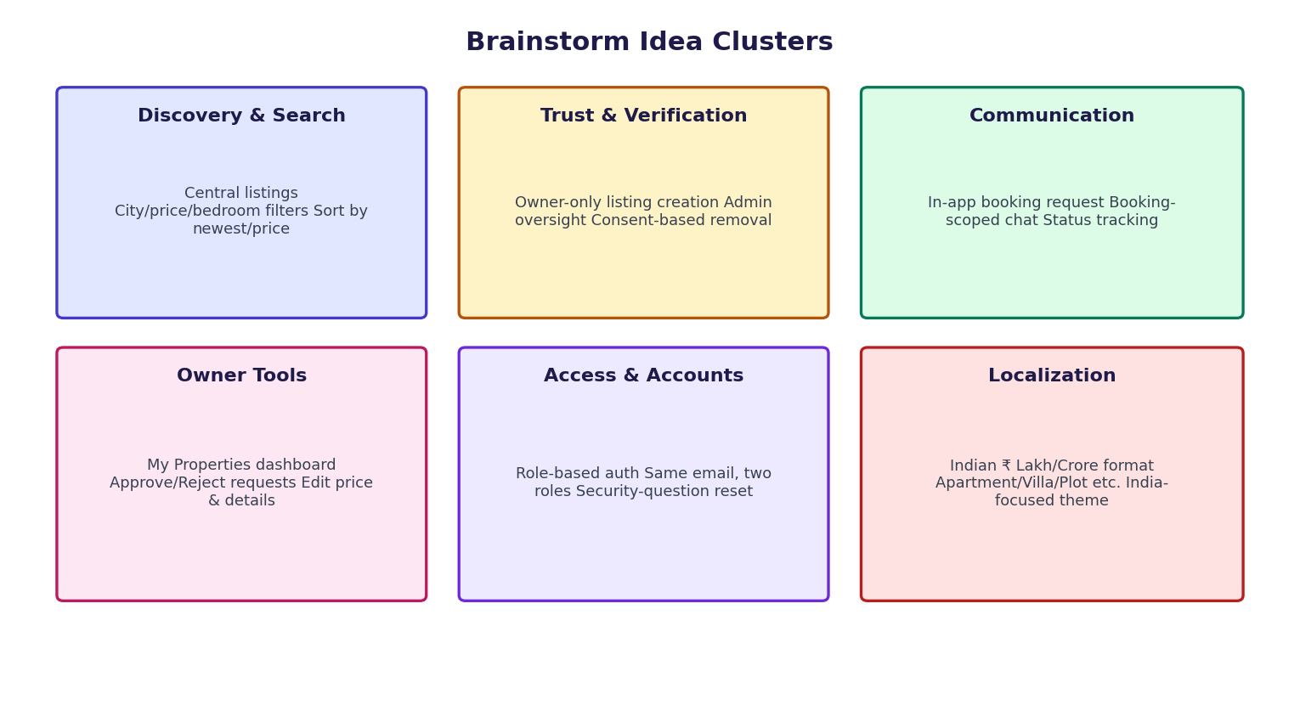
Figure 1: Brainstormed ideas grouped by theme

Theme | Ideas
Discovery & Search | Central property listing with photos; search by city/type; filters for price range, bedrooms, property type; sort by newest or price.
Trust & Verification | Owner-only property creation with login; admin oversight dashboard; consent-based listing removal instead of unilateral admin deletion.
Communication | In-app booking request instead of phone numbers; in-app chat thread once a booking request is sent; status tracking (pending/approved/rejected).
Owner Tools | Owner dashboard for "My Properties" and "Booking Requests"; one-tap approve/reject; ability to edit price/details after listing; image uploads.
Access & Accounts | Role-based accounts (Renter/Buyer, Owner, Admin); same email usable for both a renter and an owner account; no-email "forgot password" via a security question.
Localization | India-focused: Indian-style price formatting (₹ Lakh/Crore), Indian property categories (Apartment, Independent House, Villa, Studio, Plot, Commercial).

Step-3: Idea Prioritization
Ideas were scored on Impact (value to the user) and Feasibility (effort to build within the MERN stack) to decide what ships first.
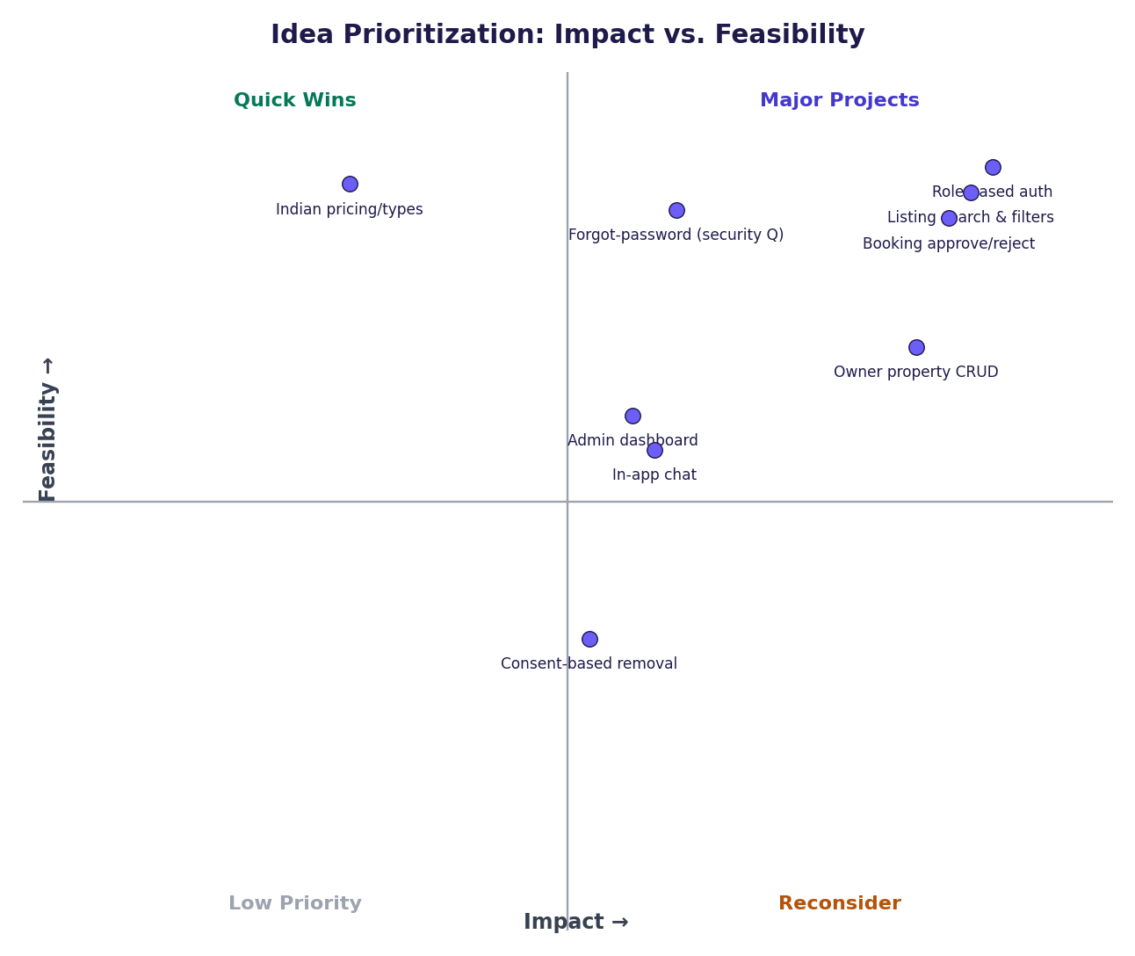
Figure 2: Idea prioritization — impact vs. feasibility

Idea | Impact | Feasibility | Priority
Property listing with search & filters | High | High | Must-have — Sprint 1
Role-based auth (Renter/Owner/Admin) | High | High | Must-have — Sprint 1
Booking request + approve/reject workflow | High | High | Must-have — Sprint 1
Owner property CRUD with image upload | High | Medium | Must-have — Sprint 1
Admin dashboard (stats, users, listings) | Medium | Medium | Should-have — Sprint 2
In-app chat per booking | Medium | Medium | Should-have — Sprint 2
Consent-based listing removal flow | Medium | Low | Could-have — Sprint 2
Indian price formatting & property types | Low | High | Could-have — Sprint 2
Forgot-password via security question | Medium | High | Should-have — Sprint 1

